# Overall Condition/Decision Making Practice

Read the following statements carefully and draw flow chart diagram foe each problem. Then write down necessary C code to solve the problems.   
  
  
**Problem 1:** **Your father know that you are good at programming, now he is asked you to write a C program that can take input the age of your father, mother and uncle and your program should output who is the oldest, who is youngest and whose age is between oldest and youngest.   
  
Sample Input:**  
Enter your father age: 35  
Enter your mother age: 30  
Enter your uncle age: 40  
  
**Sample output:**  
Your uncle is the oldest person.  
Your mother is the youngest person.  
Your father's age is between oldest and youngest age.   
  
  
**Problem 2: See the attached image and solve the below problem.**

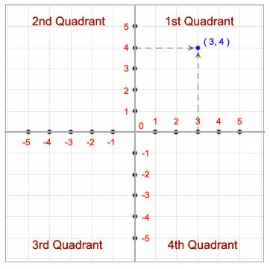  
We know there are four quadrants named 1st, 2nd, 3rd and 4th quadrant. Your task is to **write a c program** that can take input of the values of  **X & Y Coordinates.**Now your program should output in which quadrant inputted coordinates lies.   
  
**Sample input:**  
**1.**  
Please enter the value of X coordinate point: 12.5  
Please enter the value of Y coordinate point: 10  
**2.**  
Please enter the value of X coordinate point: -7  
Please enter the value of Y coordinate point: 9.6  
**3.**  
Please enter the value of X coordinate point: -2  
Please enter the value of Y coordinate point: -9  
**4.**  
Please enter the value of X coordinate point: 8  
Please enter the value of Y coordinate point: -7  
  
  
**Sample output:**  
**1.**  
Inputted coordinate (12.5,10) lies in 1st Quadrant  
**2.**  
Inputted coordinate (-7.5,9.6) lies in 2nd Quadrant  
**3.**  
Inputted coordinate (-2,-9) lies in 3rd Quadrant  
**4.**  
Inputted coordinate (8, -7) lies in 4th Quadrant  
  
  
**Problem 3: Write a**C program that can convert temperature from degree celcius to farenheit and farenheit to celcius.   
  
For your convenience the formula is given below:  
Celcius to farenheit = (**C** × 9/5) + 32   
Farenheit to cecius = (**F** − 32) × 5/9   
**Sample input:**  
1. Celcius to Farenheit  
2. Farenheit to Celcious  
Please enter your choice: 1  
Enter the temparature in celcius: 37   
  
  
**Sample Output:**  
37 celcius is 98.6 farenheit

**Problem 4: Simple calculator**

Think about a simple calculator. You need to take two number as user input and then provide various options to the user like sum, subtract, multiply, divide. Now let user chose what to do. Based on the user’s choice do the calculation and display result.

Example:

Please insert the first number: 110

Please insert the second number: 11

What do you want to do with the inputted numbers?

1. Calculate the summation
2. Calculate the subtraction
3. Calculate the multiplication
4. Calculate the division

Enter your choice: 2

The summation of 110 and 11 is = 121

**Problem 5:**

**Write down C codes for following cases:**

* 1. Take an integer variable named currentNumber. If integer variable currentNumber is odd, change its value so that it is now 3 times currentNumber plus 1, otherwise change its value so that it is now half of currentNumber (rounded down when currentNumber is odd).
  2. Assign a value to double variable cost depending on the value of integer variable distance as follows:

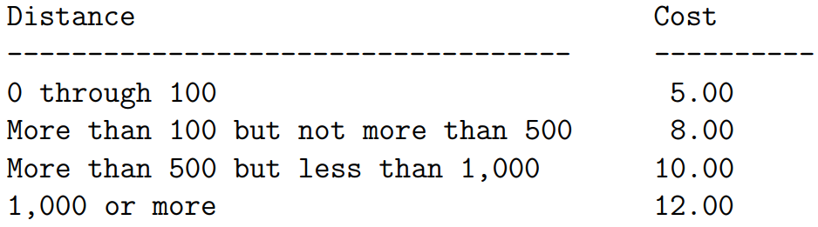

**Problem 6: Gregorian Leap year**

In the Gregorian calendar, a normal year consists of 365 days. Because the actual length of a sidereal year (the time required for the Earth to revolve once about the Sun) is actually 365.2425 days, a "leap year" of 366 days is used once every four years to eliminate the error caused by three normal (but short) years. Any year that is evenly divisible by 4 is a leap year: for example, 1988, 1992, and 1996 are leap years.

However, there is still a small error that must be accounted for. To eliminate this error, the Gregorian calendar stipulates that a year that is evenly divisible by 100 (for example, 1900) is a leap year only if it is also evenly divisible by 400.

For this reason, the following years are not leap years:

1700, 1800, 1900, 2100, 2200, 2300, 2500, 2600

This is because they are evenly divisible by 100 but not by 400.

The following years are leap years: 1600, 2000, 2400

This is because they are evenly divisible by both 100 and 400.  
**Now, consider the above scenario write down necessary c codes to make a leap year calculator.**

**Problem 7: BMI**

BMI is calculated the same way for both adults and children. The calculation is based on the following formulas:

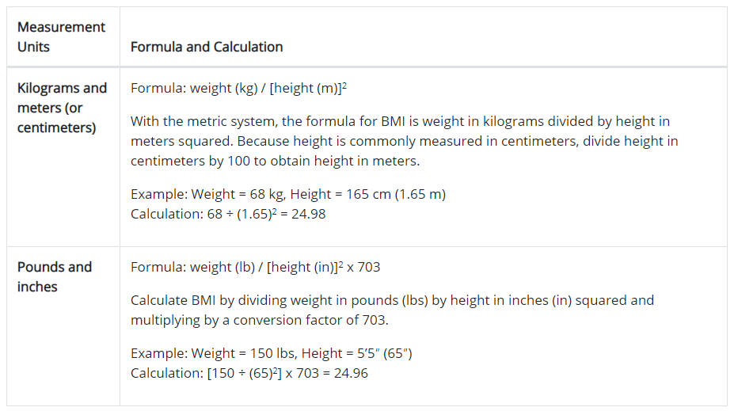

**BMI Inter Predation in Adults:**

For adults 18 years old and older, BMI is interpreted using standard weight status categories. These categories are the same for men and women of all body types and ages.

**The standard weight status categories associated with BMI ranges for adults are shown in the following table-**

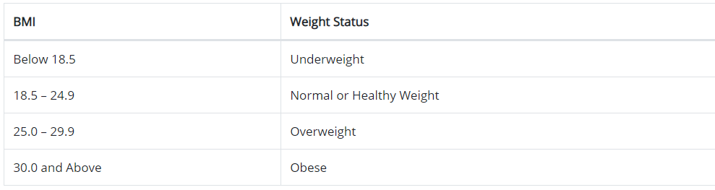

**For example, here are the weight ranges, the corresponding BMI ranges, and the weight status categories for a person who is 5′ 9″**

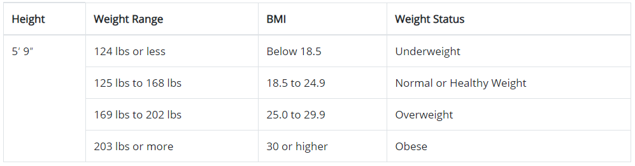

**Let’s say you take input 70 cm height and 70 kg weight now you need to calculate BMI and then need to decide BMI Weight Status.**

Now write necessary codes for implementing an BMI Calculator in C.

**Problem 8:**

In a town, the percentage of men is 52. The percentage of total literacy is 48. If total percentage of literate men is 35 of the total population, write a program to find the total number of illiterate men and women if the population of the town is 80,000.

**Problem 9:**

A cashier has currency notes of denominations 10, 50 and 100. If the amount to be withdrawn is input through the keyboard in hundreds, find the total number of currency notes of each denomination the cashier will have to give to the with-drawer.